**Commercial Banking Operations**

Commercial banks provide a range of financial services to individuals, businesses, and governments. Their primary operations include:

1. **Accepting Deposits**:
   * **Savings Accounts**: Interest-bearing accounts where customers can deposit money.
   * **Checking Accounts**: Accounts primarily for transactions, usually offering no or low interest.
   * **Fixed Deposits (Time Deposits)**: Accounts where money is deposited for a fixed term at a higher interest rate.
   * **Interest Rates:** Savings accounts might offer an annual interest rate of 0.5-2%, while fixed deposits could offer 2-5% depending on the term and amount
2. **Lending Services**:
   * **Personal Loans**: Loans to individuals for personal use.
   * **Business Loans**: Loans to businesses for various purposes such as capital expenditure or working capital.
   * **Mortgages**: Loans specifically for purchasing real estate.
   * **Interest Rates:** Commercial loans often have interest rates ranging from 4-10%, depending on the borrower's creditworthiness and loan terms.
3. **Payment and Settlement Services**:
   * **Wire Transfers**: Electronic transfer of funds.
   * **Credit/Debit Card Services**: Issuing cards for transactional use.
   * **Clearing and Settlement**: Processing checks and electronic payments.
4. **Other Services**:
   * **Wealth Management**: Advisory services for managing wealth.
   * **Insurance**: Offering various insurance products.
   * **Foreign Exchange Services**: Currency exchange and related services.

**Example: Loan Interest Calculation**

Suppose a commercial bank offers a business loan of $100,000 at an annual interest rate of 5% for 3 years, with annual compounding. The amount to be repaid can be calculated as follows:

A=P(1+rn)ntA = P \left(1 + \frac{r}{n}\right)^{nt}A=P(1+nr​)nt

Where:

* AAA = amount to be repaid
* PPP = principal amount ($100,000)
* rrr = annual interest rate (0.05)
* nnn = number of times interest is compounded per year (1)
* ttt = number of years (3)

A=100,000(1+0.051)1×3A = 100,000 \left(1 + \frac{0.05}{1}\right)^{1 \times 3}A=100,000(1+10.05​)1×3 A=100,000×(1.05)3A = 100,000 \times (1.05)^3A=100,000×(1.05)3 A=100,000×1.157625A = 100,000 \times 1.157625A=100,000×1.157625 A=115,762.50A = 115,762.50A=115,762.50

So, the total repayment amount after 3 years is $115,762.50.

**Table: Types of Deposits and Their Characteristics**

| **Type of Deposit** | **Interest Rate** | **Liquidity** | **Term Length** | **Special Features** |
| --- | --- | --- | --- | --- |
| Savings Account | Low | High | None | Typically low minimum balance |
| Checking Account | None/Low | Very High | None | Unlimited transactions |
| Fixed Deposit | High | Low | 1 month to 10 years | Higher interest for longer terms |

**Commercial banks rely on deposits from customers as a primary source of funding for lending activities.**

**These deposits are categorized into various types, such as checking accounts, savings accounts, and certificates of deposit.**

|  |  |
| --- | --- |
| Deposit Type | Balance (Billions) |
| Checking Accounts | 100 |
| Savings Accounts | 50 |
| Certificates of Deposit | 25 |

**The loan portfolio represents the loans extended by the bank to borrowers.**

**Loans are classified based on their purpose, such as mortgages, commercial loans, and consumer loans.**

|  |  |
| --- | --- |
| **Loan Type** | **Balance (Billions)** |
| **Mortgages** | **150** |
| **Commercial Loans** | **75** |
| **Consumer Loans** | **25** |

**Investment Banking Operations**

Investment banks engage in various financial services primarily related to the financial markets. Their main operations include:

1. **Underwriting**:
   * **Initial Public Offerings (IPOs)**: Assisting companies in going public by issuing stocks.
   * **Debt Issuance**: Helping companies and governments raise funds through bond issuance.
2. **Advisory Services**:
   * **Mergers and Acquisitions (M&A)**: Advising on corporate mergers and acquisitions.
   * **Corporate Restructuring**: Advising on financial restructuring of companies.
3. **Sales and Trading**:
   * **Securities Trading**: Buying and selling securities on behalf of clients or the bank itself.
   * **Market Making**: Providing liquidity to markets by being ready to buy or sell at publicly quoted prices.
4. **Asset Management**:
   * **Portfolio Management**: Managing investment portfolios for institutions and individuals.
   * **Hedge Funds**: Managing alternative investment funds aimed at high returns.
5. **Research**:
   * **Equity Research**: Analyzing stocks and providing investment recommendations.
   * **Economic Research**: Providing macroeconomic analysis and forecasts.

**Example: IPO Underwriting**

Suppose an investment bank underwrites an IPO for a company planning to issue 1 million shares at $10 each. The bank agrees to a firm commitment underwriting, meaning it buys all shares and resells them to the public. If the bank charges a 7% underwriting fee, the calculations are:

* **Gross Proceeds**: 1,000,000×10=$10,000,0001,000,000 \times 10 = \$10,000,0001,000,000×10=$10,000,000
* **Underwriting Fee**: 10,000,000×0.07=$700,00010,000,000 \times 0.07 = \$700,00010,000,000×0.07=$700,000
* **Net Proceeds to Company**: 10,000,000−700,000=$9,300,00010,000,000 - 700,000 = \$9,300,00010,000,000−700,000=$9,300,000

**Table: Comparison of Underwriting Types**

| **Underwriting Type** | **Description** | **Risk to Underwriter** | **Risk to Issuer** |
| --- | --- | --- | --- |
| Firm Commitment | Underwriter buys all shares and resells them to public | High | Low |
| Best Efforts | Underwriter sells as many shares as possible but does not buy the shares | Low | High |
| All-or-None | Underwriter cancels the issue if it cannot sell all the shares | Low | Moderate |
| Standby | Underwriter agrees to buy any unsold shares in a rights offering | Moderate | Low |

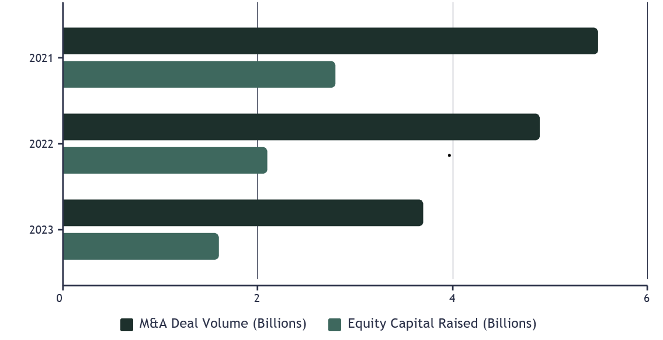

**Comparison Table**

| **Feature** | **Commercial Banking** | **Investment Banking** |
| --- | --- | --- |
| Clients | Individuals, small to large businesses | Corporations, governments, institutional investors |
| Key Services | Deposits, loans, payment processing, treasury services | Underwriting, M&A advisory, sales and trading, asset management |
| Revenue Sources | Interest on loans, fees from services | Underwriting fees, advisory fees, trading commissions, management fees |
| Example Products | Savings accounts, commercial loans, credit lines | IPOs, bond issues, mergers and acquisitions, trading |
| Interest Rates | Loans: 4-10%, Deposits: 0.5-5% | N/A (fees-based) |
| Transaction Examples | $1M loan at 6%, $500K deposit at 1.5% | $100M bond issue at 2% fee, $500M M&A at 1% fee |